EGERTON UNIVERSITY

Software Requirements Specification

for

Student Systems Project Management System
Prepared by Jackline Achieng’ Mboya
Supervisor: Mr. Kimani Njoroge
Coordinator: Dr. Wilfred Gikaru
14th Nov 2019
VERSION 1.0

TABLE OF CONTENTS
Contents
TABLE OF CONTENTS i
Revision History iii
1. Introduction 1
1.1 Purpose 1
1.2 Document Conventions 1
1.3 Intended Audience and Reading Suggestions 2
1.4 Project Scope 2
2. Overall Description 2
2.1 Product Perspective 3
2.2 Product Features 3
2.3 User Problem statement 6
2.4 User Objectives 6
2.5 Operating Environment 6
2.6 Design and Implementation Constraints 7
2.7 User Documentation 7
2.8 Assumptions and Dependencies 7
2.9 User Constraints 8
3. System Features 8
3.1 User Authentication and Registration 8
3.2 Uploading, displaying and Sending Project Document 9
3.3 Group Project Management 11
4. External Interface Requirements 12
4.1 User Interfaces 12
4.2 Hardware Interfaces 12
4.3 Software Interfaces 12
4.4 Communications Interfaces 12
5. Other Non-functional Requirements 13
5.1 Performance Requirements 13
5.2 Safety Requirements 13
5.3 Security Requirements 13
5.4 Software Quality Attributes 13
5.5 Other requirements Attributes 14
6. Preliminary Object-Oriented Domain Analysis 14
6.1 Inheritance relationships 14
6.2 User Classes and Characteristics 14
7. Preliminary Budget and Schedule 18
8. Other Requirements 20
8.1 References 20
8.2 Appendix A: Glossary of definitions, Acronyms and abbreviations 20

Revision History
Name | Date | Reason For Changes | Version
Student Systems Project Management System | 14/11/2019 | First Revision | 1.0

Overview
SRS is the official statement of what the system developers should implement. SRS is a complete description of the behavior of the system to be developed. SRS should include both a definition of user requirements and a specification of the system requirements.
The SRS fully describes what the software will do and how it will be expected to perform. The SRS precisely defines the software product that will be built. SRS used to know all the requirements for the software development and thus that will help in designing the software. It provides feedback to the customer. Documents that describe the functions of the SRS include the Software Requirements Document (SRD), Functional Requirements Document (FRD), Functional Requirements Specifications document (FRS), among other synonyms.
The SRS defines the contract between the developer and the systems owner.

1. Introduction

1.1 Purpose
The purpose of this document is to give a detailed description of the SRS and to capture all the necessary functions and capabilities of the Student Systems Project Management System that is intended as an online platform for project monitoring/management. This is the first version of the system. The SRS document illustrates all the software requirements of the proposed system and how the system will be designed in regards to those requirements. In addition, this document also explains the interfaces, constraints and performance requirements of the proposed system. The SRS document will also serve as a guide to the developer and designer and as a software validation document to a prospective user. The document will be subject to change if more requirements are added to the system.

Document Conventions
This section describes how the SRS is presented in terms of documentation that is the style, spacing and the font size. The style of writing used is Times New Roman with a font size of 12 and a spacing of 1.5. the acronyms used are:
SRS – Software Requirement Specification
SSPMS – Student Systems Project Management System

Intended Audience and Reading Suggestions
This SRS simplifies the complexity involved in the implementation of SSPMS so that the intended user can easily understand the system. The SRS also explains the high level structure of the proposed system in terms of functions, performance, external interfaces and design hence creating a clearer understanding of the system to both developers and the users. This documents acts as a guideline to developers, the project manager and to those who will be testing and deploying the SSPMS.

Project Scope
The SSPMS will be an online platform for submitting project documents for reviewing and validating the documents. It will also provide a way for supervision and coordination of the project work. It’s intended purpose is to provide an automated system which will be used to project supervision and coordination process. The proposed system will provide a platform where the students can send their documents to their various supervisors and a copy to the coordinator immediately they are done writing the document for reviewing and validation as they wait for a go ahead feedback from the supervisor. This will ensure that the student won’t be waiting for the supervisor in cases where the supervisor will not be available to check the student’s progress on the project. The system will provide a platform where the supervisor can give a suggestion on what’s need to be done on a particular document.
The benefits of the system will include, the supervisor and the coordinator will have a good record on when the student sent the document and what document the student did send.

2. Overall Description
This section describes the overall description of the proposed system in terms of the product perspective, product features, user problem statement, user objective, operating environments of the product, design and implementation constraints, user documentation, assumptions and dependencies and user constraints.

Product Perspective
The product specified is SSPMS, which seeks to replace the current manual system used to supervise and manage the project work in an institution. The current system has list of activities/documents printed so that the student has to go to his/her supervisor to sign beside the documents already submitted and to verify if the document submitted meets the requirements illustrate before the student can proceed to the next phase of the project. Thus the student will not have marks recorded by the coordinator for the sign off sheet in cases where the supervisor is out for various reasons and couldn’t sign. The proposed system will ensure that the coordinator gets the exact date and time the student sent the documents and therefore the marks for the sign off sheet will be recorded despite the supervisor’s presence or not. The proposed system will also ensure that information is maintained in a normalized way to ensure easy retrieval of documents. The proposed system will provide a visualization of the whole project process, giving a clear overview of how this as tracking along.
This system will interact with the database system and the interface between the systems is shown below.
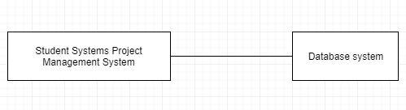

Product Features
The proposed system is aimed at developing a system for supervision of various students’ projects in an institution and it will provide the following functionalities to the users;
- Registration of users, that is, students will be registered along with their supervisors after selecting the project topic and has been approved by the coordinator to allow the student work on the selected topic.

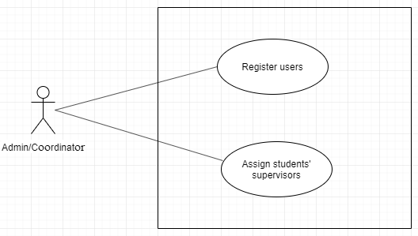
- The system will allow students to upload documents to their supervisors for reviewing and the supervisors will then be able to send a feedback regarding the document sent.

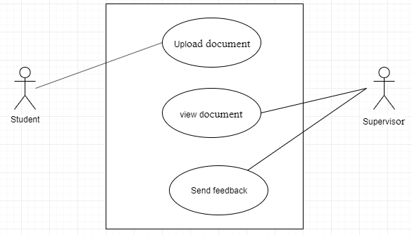
- The system will be able to show when and what was uploaded and when the feedback was sent to prevent deferment of the project course in cases where the student is blamed to have submitted in the documents late.
- The system will be capable of managing the student’s grade regarding the project work.
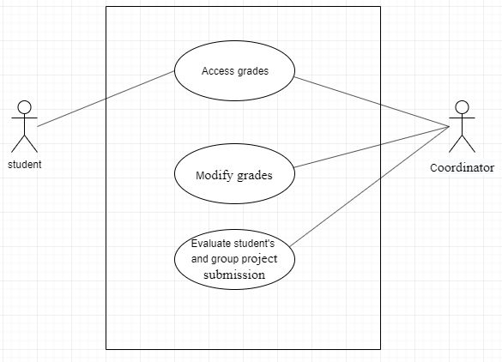
- The system will support group project management features.
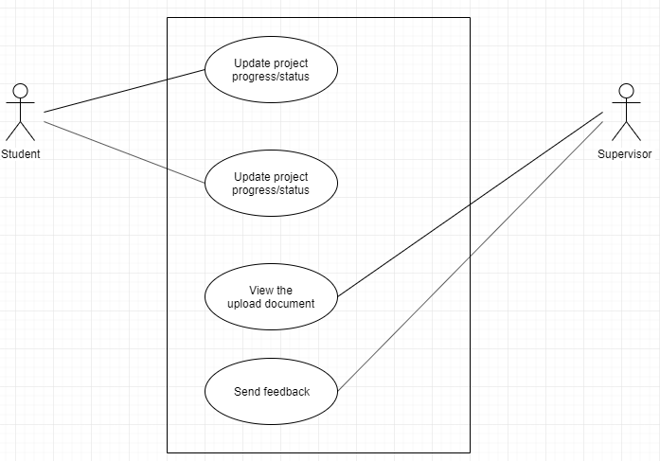

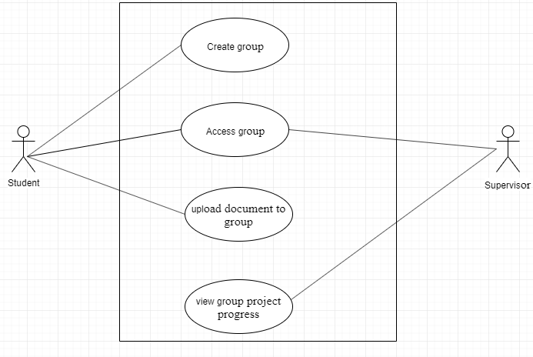

- The system will allow students to update project status between the agreed time frame period.

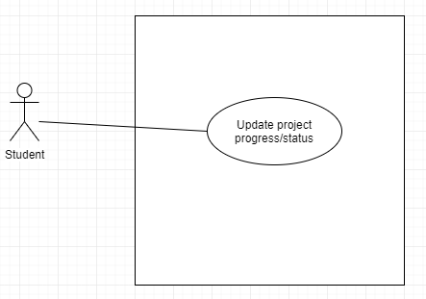

User Problem statement
All registered users must have the capabilities to use have an internet access device that can allow them to login, upload the document(s), update the project status and/also their profile, review and send feedback. This may be laptop, desktop or mobile device.

User Objectives
This section describes the set of objectives and requirements of the SSPMS from the user’s perspective. The following are the objectives of the main users of the system.
- Students to be able to get a platform where they can easily send the project document(s) and to get feedback as quick as possible.
- To be able to get a platform where the students and lectures/supervisors can interact freely in cases where student needs to consult his/her supervisor on a certain issue.
- To be able to get a platform where information can be stored for future references and the information can be retrieved for various reasons.
- To get a platform where the admin

2.5 Operating Environment
The proposed system will be a web-based system and therefore will operate on any operating system (window-based system, Unix operating system, android or iOS system).

Design and Implementation Constraints
- The system shall be maintained by developers who will take care of any updates in any case they are required.
- The system shall be secured from intrusion by malicious parties who may use the users account in the system to upload unnecessary information that is not credible, thus password encryption shall hence be implemented.
- The system will require an active internet connection on the device it has been deployed for it to effectively provide all its intended functionalities.

Interface and structure.
- HTML5
- CSS3
- Bootstrap
Development of the System
- PHP

Database Management System
- SQLite.
Development tools
- Lucid Charts
- Draw.io

User Documentation
The user documentation components that will be delivered along with the software will be the user manuals which users will use to understand how the system works.

Assumptions and Dependencies
The assumption factors include the following:
- It is assumed that all the users will access the system via the internet
- It is assumed that the third party tools and applications software wherever required to fulfill the functionality of the software will be available on the machines where such features will be executed. These may include office tools for viewing the PDF and charts generated by the package.
- The web browser shall be latest and all the plug-ins will work on the user’s machines to access the system.
- Common features including Login, Logout, forgot password, Change Password, User management features etc. which will be used across all software applications as part of the Project will be developed commonly and uniformly.
- The web services provided by the external server are able to give the data.

User Constraints
The application performance and speed will be dependent on the internet connectivity speed of the user’s device. The user interface will be friendly enough to guide the user.

3. System Features
This section describes the distinctive features of the SSPMS.

User Authentication and Registration
3.1.1 Description and Priority
If the user(s) will be accessing the system for the first time, the system administration will log into the system and input all the credentials. Once all the information has been processed, the user account will be created and stored in the database. The user will therefore be able to access other functionalities within the system. Otherwise, if the user already has an account, he/she will be requested to enter his/her email, and password to complete authentication.
3.1.2 Stimulus/Response Sequences
- The user logs into the system by entering his/her email and password for authentication. If the user is not registered, the system administration logs into the system.
- Admin adds a new user and specifies whether the user is a supervisor, coordinator or student.
- The information is sent to the database.
- Registration is complete and the user will be directed to the Home Page.
3.1.3 Functional Requirements
REQ-1: User cannot proceed without a valid email address. The email address should be in a specific format example aaa@aaa.com.
REQ-2: A valid password will be required for the user to proceed to access other functionalities of the system.
3.1.4 Technical Issues
In case of the user entering the wrong credentials, they will be denied access to the system.
3.1.5 Dependencies with other requirements
This feature of the system requires that the administration first logs into the system using his/her Identification number and password for him/her to register new users of the system.

3.2 Uploading, displaying and Sending Project Document
3.2.1 Description and Priority
The registered users (students) will be able to upload project document and send the document to the supervisor for reviewing and a copy of each document to the coordinator.
3.2.2 Stimulus/Response Sequences
- Registered users (students) logs into the system.
- Selects upload a new file or document.
- Display the document.
- Send the uploaded file to the supervisor.
3.2.3 Functional Requirements

REQ-1: Login of the registered user.
The system must provide login functionality for this portion of the system
to be implemented.
REQ-2: There must be a selected file to be uploaded for this feature to function.

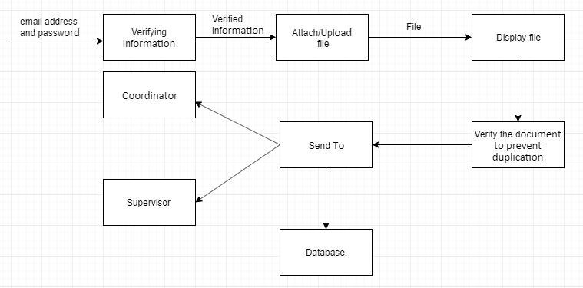
3.2.4 Technical Issues
An error message will appear on the screen if a user tries to upload/send nothing.
3.2.5 Dependencies with other requirements
This feature requires that the registered user first of all logs into the system using his/her email and password.

Group Project Management
3.3.1 Description and Priority
The student project manager will be able to log into the system and create a group and then add members.
Members will also log into the system then join the group. The group members will then be able to upload the documents.
The supervisor will also be able to view the uploaded document.
The system will also enforce certain conditions like each student will only be a member of one group.

3.3.2 Stimulus/Response Sequences
- Registered student (who is the project manager) logs into the system.
- He then creates a group and add members to the group. The added members will be able to access the group details and perform functions like editing group name uploading project document among others.

3.3.3 Functional Requirements
REQ-1: The student shall log into the system
REQ-2: The student must be a member of a group for him to participate in a group project to prevent unnecessary errors.
3.3.4 Technical Issues
A user will be prompted to be a part of a group project first when he tries to upload any document to any group which he is not a member.
3.3.5 Dependencies with other requirements
This feature requires that a user must be part of a group before he participate in a group project.

4. External Interface Requirements

4.1 User Interfaces
The user interface consists of friendly and captivating Graphical User Interface that makes it easy for the user to navigate through the system. The user interface will not only be appealing to the eye and user friendly but it will also follow all the principles of Human Computer Interaction that maximize on having satisfactory user experience. This will include consistent colors and fonts throughout the system, simple commands, the ability to recover from errors, interaction support to give correct feedback for every task that has been performed and efficiency in performance.

4.2 Hardware Interfaces
- A computer, laptop or desktop with an Operating system, windows, Linux etc. or a mobile device with internet capabilities, running Android.
- A functional standard keyboard for any kind of computer users, on screen keyboards are also acceptable for use for this system.
- A mouse or any pointing device is also necessary to navigate the system menus, navigation bars etc.

4.3 Software Interfaces
- Any operating system could work, preferably windows for its support and user friendliness.
- SQLite server engine, for operating all the database actions.
- Web scripting languages, Html, Bootstrap and CSS for implementing the user interfaces.

4.4 Communications Interfaces
The following interfaces shall be required for communication purpose.
- Internet communications using Http protocol for client server communications purposes.
- A web browser of any kind to access the system since we are using electronic interfaces with web scripting languages.

5. Other Non-functional Requirements

5.1 Performance Requirements
Response Time – The system is expected to take as little time as possible to load. This is because time is an important factor in information search.
Reliability – This is the capability of a system to maintain the specified level of performance in any browser in any device.
Internet connection – fast internet connectivity will be required for the system to work efficiently and fast.
The system should be flexible for future enhancement.
Error handling should be implemented and the system should be able to handle all run time errors.

5.2 Safety Requirements
All user data information will be stored in a secure storage location that will be inaccessible from other users. The database is also replicated that is it will be always available despite the server failures at any given time.

5.3 Security Requirements
The system will provide for user authentication using username, email and password to ensure and authorize access to the system. The password will be encrypted and stored securely to ensure that only the user has an access to their own login credentials.

5.4 Software Quality Attributes
Portability – The system must be able to be accessed and used on various platforms/browsers and devices like tablets, desktops, mobile and laptops.
Usability – The system must be easy to use, navigate and memorability must be high to reduce memory load on users.
Correctness – The system must do exactly what it is supposed to do.
Testability – The system must be testable to prove that all properties and functions work exactly as they should.
Availability – The system must be available to all users at any time for access.

5.5 Other requirements Attributes
Maintainability – In case of failure, the system must be able to be restored successfully with minimal effort and time such that all the original purposes can be performed as before.
Reliability – The system must satisfactory implement all the purposes that was intended for it as long as the hardware and software interfaces defined remain stable and unchanged.

6. Preliminary Object-Oriented Domain Analysis
This section presents a list of the fundamental objects that must be modeled within the system to satisfy its requirements. The purpose is to provide an alternative ‘structural’ view on the requirements stated above and how they might be satisfied in the system.

6.1 Inheritance relationships
This section shows sub classes that inherit from the super class in order to use their attributes and methods in the parent class.

6.2 User Classes and Characteristics
This section describes user classes in the system and their characteristics.
6.2.1 Class descriptions
This section presents a more detailed description of each class identified during the OO Domain Analysis. For more details on the process giving rise to these descriptions, see Lecture 5.3: OO Domain Analysis and/or texts on object-oriented software development.
Each class description should conform to the following structure:
6.2.1.1 <Class name> user class
6.2.1.1.1 Abstract or Concrete:
Abstract classes.
- User class.
- Database Connection class
Concrete class
- Administration class.
- Lecturer class.
- Student class.
6.2.1.1.2 List of Super classes:
6.2.1.1.3 List of Subclasses:
Administrator.
Lecturer.
Student.
6.2.1.1.4 Purpose:
Defines all fields needed for registration of all users of the system.
The class models the user data attributes of the system and provides methods for authenticating the user.
Administrator class will have the administrator details.
Lecture class will have the lecturer’s details including the details of students he will be supervising or coordinating.
Student class will have the details of student and his supervisor and coordinator, so that when the student uploads any document it will be sent to his supervisor and coordinator.
6.2.1.1.5Collaborations:
The log in class must collaborate with the database class in order to validate the users into the system using methods provided by the database class.
The users class interacts with the system administrator class, lecturer class and student class to direct users to their respective interfaces after being validated by the database class.
The student class and lecturer class interacts with the administrator class to generate their details and update after validation by the database.
6.2.1.1.6 Attributes:
User class
Id
FirstName
LastName
EmailAddress
Password
Administrator class
Id
EmailAddress
Password
Student class.
StudentRegNo
StudentName
ProjectTitle
LecturerName
EmailAddress
Password
Lecturer class.
Id
LecturerName
StudentRegNo
StudentName
ProjectTitle
EmailAddress
Password
6.2.1.1.7 Operations:
isStudent – this method identifies if the user is a student.
isLecturer – this method identifies if the user is a lecturer (and also specifies if the lecturer is a coordinator or supervisor).
loginUser – this method logs in the user to the system using their email and password.
registerUser – allow the Admin to create account for a new user.
uploadFile – allow user (student) to upload documents for review.
viewFile – allow user (supervisor) to view the uploaded document.
6.2.1.1.8 Constraints:
The user who doesn’t have an account cannot access the system. Admin can create an account for new user. The email address used has to be unique and not already existing in the system.

7. Preliminary Budget and Schedule
This section provides an initial budget, itemized by cost factor and schedule including major tasks to be accomplished, their interdependencies and their tentative start/stop dates. The plan/schedule should also include information on hardware, software and other resources required.

Budget
Id | Particulars | Quantity | Unit price | Total price
1 | Printing expenses(printing the proposal and documentation) | - | - | 1000
2 | Internet & Airtime(Information gathering & other research) | - | - | 500
3 | Miscellaneous | - | - | 200
Total | - | - | - | 1400

Schedule
PERIOD | ACTIVITY | DESCRIPTION
SEPTEMBER 2019-MID OCTOBER 2019 | Problem Identification and concept document writing | Research had to be carried out to find out problems in the society that can be solved using technology. After identifying the problem, concept document had to be written in order for the Coordinator to approve the project Title.
MID OCTOBER 2019-MID NOVEMBER 2019 | Proposal writing | The project proposal will be written and presented to the supervisor. The supervisor will have to correct it and approve it.
MID NOVEMBER 2019 | Requirements gathering | Data relevant to this project is collected from the students and lecturers to identify the functional requirements of the project .This is done through interviews.
DECEMBER 2019 | System Design | The design of the system is carried out. This involves class designs and user interface designs
JANUARY 2020 | System implementation | Coding is done here.
FEBRUARY 2020 | System testing | The system is tested to make sure it works as expected.
MARCH 2020 | Refinement, Documentation, deployment of the system and presentation | Refining the system based on the weakness encountered during testing stage to improve the system credibility and reliability. The system documentation including user manuals are written. The system is deployed ready for user and final presentation is done.

8. Other Requirements
There are no other extra requirements

8.1 References
<List any other documents or Web addresses to which this SRS refers. These may include user interface style guides, contracts, standards, system requirements specifications, use case documents, or a vision and scope document. Provide enough information so that the reader could access a copy of each reference, including title, author, version number, date, and source or location.>

8.2 Appendix A: Glossary of definitions, Acronyms and abbreviations
The following SRS did not use any complex acronyms or definitions that need to be clarified so as to understand the document effectively.

